UNIVERSITY OF TECHNOLOGY, JAMAICA

COLLEGE/ FACULTY: Engineering and Computing

SCHOOL/ DEPARTMENT: SOE/Chemical Engineering

Final Examination, Semester 1

Module Name: Chemical Engineering Thermodynamics 1

Module Code: CHE3003

Date: December, 2012

Theory/ Practical: Theory

Groups: B.Eng.3C

Duration: 2 hours

Instructions

- ANSWER ALL QUESTIONS
- EACH QUESTION MUST BEGIN ON A NEW PAGE
- LEAVE TWO LINES BETWEEN PARTS OF A QUESTION
- READ EACH QUESTION CAREFULLY BEFORE ANSWERING
- SHOW CLEARLY ALL EQUATIONS USED FOR CALCULATIONS
- THE INTENDED MARK IS INDICATED AT THE BEGINNING OF EACH QUESTION
- ANSWER MUST BE NUMBERED IDENTICAL TO THE QUESTION BEING ANSWERED
- FORMULA SHEET, UNIT CONVERSION CHART AND PROPERTY TABLES ARE ATTACHED.

DO NOT TURN THIS PAGE UNTIL YOU ARE TOLD TO DO SO

QUESTION 1 (25 marks)
- Four moles of an ideal gas in a piston/cylinder device is compressed isothermally but irreversibly at 160°C from 3.5 bar to 7.5 bar. The work required is 37% greater than the work of reversible, isothermal compression. The heat transferred from the gas during compression flows to a heat reservoir at 50°C. Calculate the:
- entropy changes of the gas, [3]
- entropy changes of the heat reservoir, [7]
- total entropy change. [2]

- A nuclear power plant generates 620 MW; the reactor temperature is 415°C and a river with water temperature of 60°C is available.
- What is the maximum possible thermal efficiency of the plant, and what is the minimum rate at which heat must be discarded to the river? [6]
- If the actual thermal efficiency of the plant is 43% of the maximum, at what rate must heat be discarded to the river, and what is the temperature rise of the river, if it has a flowrate of 305 m³/s? [7]

QUESTION 2 (25 marks)
A system consists of 2 kg of carbon dioxide initially at 1 bar and 300 K. The system undergoes a reversible power cycle consisting of the following steps:
- 1 - 2, an isochoric process to 4 bar,
- 2 - 3, polytropic expansion with an exponent of 1.28,
- 3 - 1, isobaric compression to the initial state.
Assuming that carbon dioxide follows the ideal gas model with Cp = (7/2)R and Cv = (5/2)R and neglecting kinetic and potential energy effects:
- Sketch the cycle on a P-V diagram. [4]
- Calculate the work associated with each step of the cycle. [9]
- Calculate the heat associated with each step of the cycle. [8]
- What is the thermal efficiency of the cycle? [4]

QUESTION 3 (25 marks)
Fifty kmol per hour of sub-cooled Toluene at 325 K and 3 bar is superheated to 650 K in a steady-flow heat exchanger. If saturation temperature (T^{sat}) for Toluene at 3 bar is 426.9 K, estimate the exchanger duty (in kW).

QUESTION 4 (25 marks)
Calculate Z and $\hat{V}$ (m³/mol) for ethylene at 303.15 K and 8 bar by the following equations:
- The truncated virial equation with the following experimental values of virial coefficients:
$B=-140 {{cm}^{3}}/{mol \& C=7200 {{cm}^{6}}/{{mol}^{2}} }$ [8]
- The Soave/Redlich/Kwong (SRK) equation. [17]

TOTAL MARKS =100
END OF PAPER

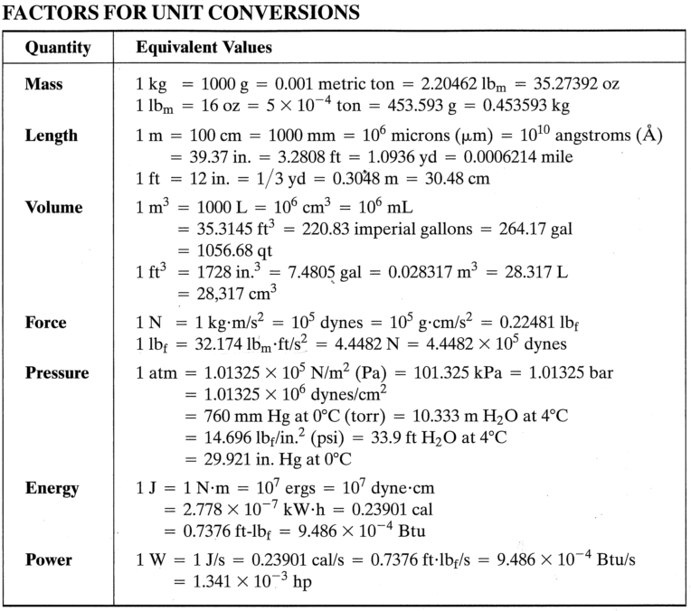

Formula Sheet

$$W_{b}=-\int_{1}^{2}{PdV}$$
$$W_{b}=-P\left(V_{2}-V_{1}\right)=-mR\left(T_{2}-T_{1}\right)$$
$$W_{b}=-P_{1}V_{1}\ln{\frac{V_{2}}{V_{1}}=-mRT\ln{\frac{V_{2}}{V_{1}}}}$$
$$W_{b}=-\frac{{(P}_{2}V_{2}-P_{1}V_{1})}{1-n}=-\frac{mR(T_{2}-T_{1})}{1-n}$$
$$Q+W=∆U+∆E_{k}+∆E_{p}$$
$$∆\hat{U}=C_{v}∆T$$
$$∆\hat{H}=C_{p}∆T$$
$$η=\frac{W}{Q_{H}}=\frac{Q_{H}-Q_{C}}{Q_{H}}=1-\frac{Q_{C}}{Q_{H}}$$
$$η_{c}=\frac{T_{H}-T_{C}}{T_{H}}=1-\frac{T_{C}}{T_{H}}$$
$$∆S=\int{\frac{dQ_{rev}}{T}}$$
$$∆S=m\left[C_{p}\ln{\frac{T_{2}}{T_{1}}-R\ln{\frac{P_{2}}{P_{1}}}}\right]$$
$$C_{p}=C_{v}+R$$
Truncated virial equation
$$\frac{P\hat{V}}{RT}=1+\frac{B}{\hat{V}}+\frac{C}{{\hat{V}}^{2}}$$

$$β=Ω\frac{P_{r}}{T_{r}}$$
$$q=\frac{Ψ α(T_{r};ω)}{Ω T_{r}}$$

For Vapour and Vapour-like Roots
$$Z=1+ β-qβ\frac{Z-β}{(Z+ϵβ)(Z+σβ)}$$
Start with $Z=1$

For Liquid and Liquid-like Roots
$$Z=β+(Z+ϵβ)(Z+σβ)\left(\frac{1+β-Z}{qβ}\right)$$
Start with $Z=β$

Riedel’s equation
$$\frac{∆H}{RT_{n}}=\frac{1.092(lnP_{c}-1.013)}{0.930-T_{r_{n}}}$$
Where, P_{c} is the critical pressure in bars and T_{rn} is the reduced temperature at T_{n}.

Watson’s equation
$$\frac{{∆H}_{2}}{{∆H}_{1}}={\frac{(1-T_{r_{2}})}{(1-T_{r_{1}}}}^{0.38}$$

$$\int_{T_{0}}^{T}{\frac{C_{p}^{o}}{R}dT}=AT_{0}\left(τ-1\right)+\frac{B}{2}T_{0}^{2}\left(τ^{2}-1\right)+\frac{C}{3}T_{0}^{3}\left(τ^{3}-1\right)+\frac{D}{T_{0}}\left(\frac{τ-1}{τ}\right)$$

$$\frac{{〈C_{p}^{o}〉}_{H}}{R}=A+\frac{B}{2}T_{0}\left(τ+1\right)+\frac{C}{3}T_{0}^{2}\left(τ^{2}+τ+1\right)+\frac{D}{τT_{0}^{2}}$$

$$∆H={〈C_{p}^{o}〉}_{H}(T-T_{0})$$

