UNIVERSITY OF TECHNOLOGY, JAMAICA
COLLEGE/ FACULTY: Engineering and Computing
SCHOOL/ DEPARTMENT: Chemical Engineering
Mid-semester Examination 1, Semester 1

Module Name: Chemical Engineering Thermodynamics 1
Module Code: CHE3003
Date: October 16, 2012
Theory/ Practical: Theory
Groups: B.ENG.3C
Duration: 1 hour & 50 minutes

Instructions
- Answer all questions.
- EACH QUESTION MUST BEGIN ON A NEW PAGE.
- LEAVE TWO LINES BETWEEN PARTS OF A QUESTION.
- SHOW CLEARLY ALL EQUATIONS USED FOR CALCULATIONS.
- ANSWERS MUST BE NUMBERED IDENTICAL TO THE QUESTION BEING ANSWERED.
- READ THE QUESTION COMPLETELY BEFORE ANSWERING.
- THE INTENDED MARK IS INDICATED AT THE BEGINING OF THE QUESTION.
- FORMULA SHEET, UNIT CONVERSION CHART AND PROPERTY TABLES ARE ATTACHED.
*** DO NOT TURN THIS PAGE UNTIL YOU ARE TOLD TO DO SO ***

For ALL Calculations: Take the work done BY the system to be negative (-ve) and the work done ON the system to be positive (+ve). NO mark will be awarded for answers with incorrect sign convention.

Question #1 [20 marks]
- The manufacturer of the device for producing power claims that it accepts a heat transfer at a rate of $\dot{Q}$_{H} = 3.0 kW from a low-grade source of geothermal heat at T_{H} = 80ºC and rejects heat at rate $\dot{Q}$_{C} to the atmosphere at T_{C} = 20ºC. The device operates at steady state and produced work at a rate of $\dot{W}$= 2.5 kW. There are no other heat or work transfers from the device.
    - What is the rate at which the device rejects heat to the atmosphere, Q_{C}? [2]
    - Is this device possible? Justify your answer. [8]

- Two Carnot engines in series between two reservoirs maintained at 500 ºC and 40 ºC, respectively. The energy rejected by the first engine is utilized as the energy input to the second engine. Determine the temperature of this intermediate reservoir between the two engines if the efficiencies of both engines are the same. [10]

Question #2 [40 marks]
The figure shown below is the P-V diagram for a thermodynamic cycle that is executed by m = 18 lbm of nitrogen gas. Assume that nitrogen behaves according to the ideal gas law with $Cp = \frac{7}{2}R$.
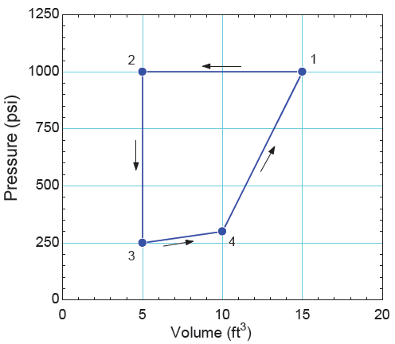
    - Determine the temperature at each of the states shown in the figure. [8]
    - Determine the enthalpy and internal energy change for each step of the cycle. [10]
    - Determine the work done and heat transfer for each step of the cycle. [16]
    - What is the efficiency of the cycle? [6]
Question #3 [40 marks]
Two air streams enter an industrial heating unit, as shown in the figure below. Stream 1 enters at T₁ = 40ºC, P₁ = 150 kPa with a volumetric flow rate of $\dot{V}$₁ = 0.30 m³/s and stream 2 enters at T₂ = 25ºC, P₂ = 100 kPa with a volumetric flow rate of $\dot{V}$₂ = 0.10 m³/s. The heating unit is equipped with an electrical resistance heater that draws $\dot{W}$_{e} = 11.5 kW. The air exits the unit at T₃ = 55ºC, P₃ = 105 kPa. The heating unit experiences a heat transfer with the surroundings at T∞ = 25 ºC. The heating unit operates at steady state. Model air as an ideal gas with constant specific heat capacity, $Cp = \frac{7}{2}R$.
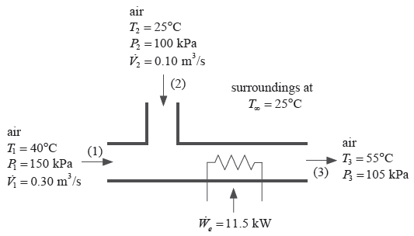
- Determine the mass flow rate of air exiting the heating unit at state (3). [10]
- Determine the rate of heat transfer FROM the device to the surroundings. [13]
- Determine the total rate of entropy generation resulting from operating the device. [17]

Total Marks = 100

***** END OF PAPER *****

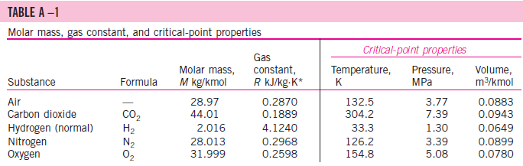
Formula Sheet

$$W_{b}=-\int_{1}^{2}{PdV}$$
$$W_{b}=-P\left(V_{2}-V_{1}\right)=-mR\left(T_{2}-T_{1}\right)$$
$$W_{b}=-P_{1}V_{1}\ln{\frac{V_{2}}{V_{1}}=-mRT\ln{\frac{V_{2}}{V_{1}}}}$$
$$W_{b}=-\frac{{(P}_{2}V_{2}-P_{1}V_{1})}{1-n}=-\frac{mR(T_{2}-T_{1})}{1-n}$$
$$Q+W=∆U+∆E_{k}+∆E_{p}$$
$$∆H+\frac{∆u^{2}}{2}+g∆z=Q+W_{s}$$
$$Q_{H}=Q_{C}+W$$
$$η=\frac{W}{Q_{H}}$$
$$η_{c}=\frac{T_{H}-T_{C}}{T_{H}}=\frac{Q_{H}-Q_{C}}{Q_{H}}$$
$$∆\hat{S}=C_{p}\ln{\frac{T_{2}}{T_{1}}-R\ln{\frac{P_{2}}{P_{1}}}}$$
$$∆S=\int{\frac{dQ_{rev}}{T}}$$
$$∆\hat{U}=C_{v}∆T$$
$$∆\hat{H}=C_{p}∆T$$
$$C_{p}=C_{v}+R$$
$$PV=znR_{u}T$$
$$∆{(\hat{S}\dot{m})}_{fs}+\frac{d{(m\hat{S})}_{cv}}{dt}+\frac{dS_{surr}}{dt}={\dot{S}}_{G}≥0$$
$$\frac{dS_{surr}}{dt}=\sum_{j}{\frac{{\dot{Q}}_{j}}{T_{σ, j}}}$$
