UNIVERSITY OF TECHNOLOGY, JAMAICA
COLLEGE/ FACULTY: Faculty of Engineering and Computing
SCHOOL/ DEPARTMENT: SOE/Chemical Engineering
Mid-semester Examination 1, Semester 1

Module Name: Chemical Engineering Thermodynamics 1
Module Code: CHE3003
Date: October 8, 2013
Theory/ Practical: Theory
Groups: B.ENG.3C
Duration: 1 hour & 45 minutes

Instructions
- Answer all questions.
- EACH QUESTION MUST BEGIN ON A NEW PAGE.
- LEAVE TWO LINES BETWEEN PARTS OF A QUESTION.
- SHOW CLEARLY ALL EQUATIONS USED FOR CALCULATIONS.
- ANSWERS MUST BE NUMBERED IDENTICAL TO THE QUESTION BEING ANSWERED.
- READ THE QUESTION COMPLETELY BEFORE ANSWERING.
- THE INTENDED MARK IS INDICATED AT THE BEGINING OF THE QUESTION.
- FORMULA SHEET, UNIT CONVERSION CHART AND PROPERTY TABLES ARE ATTACHED.
*** DO NOT TURN THIS PAGE UNTIL YOU ARE TOLD TO DO SO ***

Question #1 [20 marks]
The piston-cylinder apparatus shown in Figure 1 contains air at T₁ = 25°C and P₁ = 105 kPa. The piston is initially z₁ = 0.64 m above the cylinder bottom and is held in place by a lock. The cross-sectional area of the piston is A_{c} = 0.05 m². A weight is now placed on the piston. The lock is released and the piston falls. After a period of time, heat transfer between the air in the cylinder and the surroundings (which are at T_{amb} = 25°C and P_{atm} = 101.3 kPa) restores the air temperature to T₂ = 25°C. At this point, the piston is z₂ = 0.58 m above the cylinder bottom.
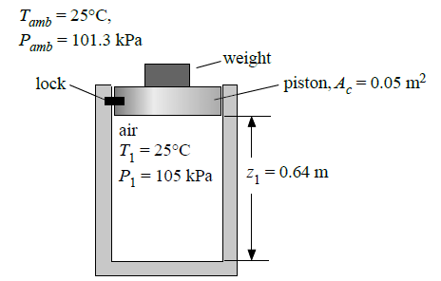
Figure 1: Piston cylinder apparatus

    - Determine the combined mass of the piston and weight. [10]
    - Determine the work done (including direction) during this process. [5]
    - Determine the heat transfer (including direction) this process. [5]
N.B. Clearly state what is being taken as the system.

Question #2 [20 marks]
One kmol of an ideal gas, initially at 303.15 K and 1 bar, undergoes the following mechanically reversible changes. It is compressed isothermally to a point such that when it is heated at constant volume to 393.15 K its final pressure is 12 bar. Sketch the process on a P-V graph and calculate Q, W, ΔU, and ΔH for the process. Take C_{p} = (7/2)R and C_{v} = (5/2)R.

Question #3 [30 marks]
Using the Soave/Redlich/Kwong equation, estimate the mass of ethylene (in kg) contained in a 0.25 m³ cylinder at 323.15 K and 115 bar. Justify your choice of equation.

Total Marks = 70

***** END OF PAPER *****

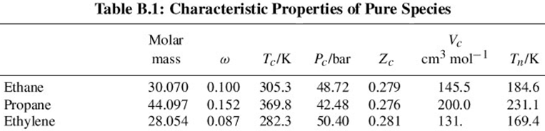
Formula Sheet

$$W_{b}=-\int_{1}^{2}{PdV}$$
$$W_{b}=-P\left(V_{2}-V_{1}\right)=-mR\left(T_{2}-T_{1}\right)$$
$$W_{b}=-P_{1}V_{1}\ln{\frac{V_{2}}{V_{1}}=-mRT\ln{\frac{V_{2}}{V_{1}}}}$$
$$Q+W=∆U+∆E_{k}+∆E_{p}$$
$$∆\hat{U}=C_{v}∆T$$
$$∆\hat{H}=C_{p}∆T$$
$$PV=znR_{u}T$$

$$β=Ω\frac{P_{r}}{T_{r}}; q=\frac{Ψ α(T_{r};ω)}{Ω T_{r}}$$

For Vapour and Vapour-like Roots
$$Z=1+ β-qβ\frac{Z-β}{(Z+ϵβ)(Z+σβ)}$$
Start with $Z=1$

For Liquid and Liquid-like Roots
$$Z=β+(Z+ϵβ)(Z+σβ)\left(\frac{1+β-Z}{qβ}\right)$$
Start with $Z=β$

