Chapter 1 HW
A 200-dm3 constant-volume batch reactor is pressurized to 20 atm with a mixture of 75% A and 25% inert. The gas-phase reaction is carried out isothermally at 227 C.

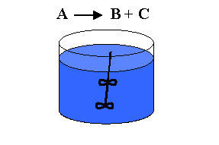
V = 200-dm³
P = 20 atm
T = 227 C

- Assuming that the ideal gas law is valid, how many moles of A are in the reactor initially? What is the initial concentration of A?
- If the reaction is first order:
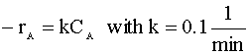
Calculate the time necessary to consume 99% of A.
- If the reaction is second order:
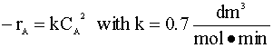
Calculate the time to consume 80% of A. Also calculate the pressure in the reactor at this time if the temperature is 127 C.

