10. Catalysis and Catalytic Reactors

Additional Homework Problems

CDP10-H_{A}
Experimental data for the gas-phase catalytic reaction
is shown below. The limiting step in the reaction is known to be irreversible, so that the overall reaction is irreversible. The reaction was carried out in a differential reactor to which A, B, and C were all fed.
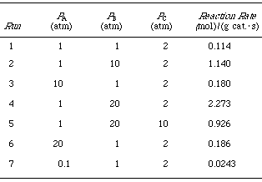
(a) Sketchas a function of P _{A} , as a function of P _{B} , and as a function of P _{C}.
(b) From your observations in part (a), which species would appear in the numerator of the rate expression? Which species would appear in the denominator of the rate expression? To what power is the denominator raised?
(c) From your conclusions from part (b), suggest a rate law consistent with the experimental data.
(d) Evaluate the rate law parameters.
(e) From your rate expression, which species can you conclude are adsorbed on the surface?
(f) From your conclusions in part (e), suggest a mechanism and rate-limiting step for this reaction.
(g) For an entering partial pressure of A of 2 atm in a PBR, what is the ratio of sites of A to C sites at 80% conversion of A? At what conversion are the number of A and C sites equal?

