Unit 1
2k11 Sem 1 Mid semester Test 1b
Question #3 [50 marks]
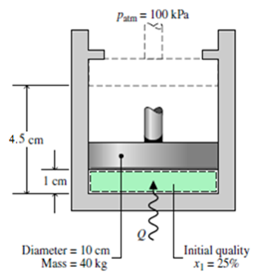
A two-phase liquid–vapor mixture of H₂O with an initial quality of 25% is contained in a piston–cylinder assembly as shown in the Figure. The mass of the piston is 40 kg, and its diameter is 10 cm. The atmospheric pressure of the surroundings is 1 bar. The initial and final positions of the piston are shown on the diagram. As the water is heated, the pressure inside the cylinder remains constant until the piston hits the stops. Heat transfer to the water continues until its pressure is 3 bar. Friction between the piston and the cylinder wall is negligible. Determine the total amount of heat transfer, in J. Let g = 9.81 m/s².

2k11 Sem 1 Final
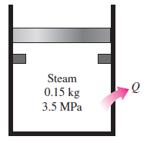
QUESTION 1 (30 Marks)
A piston–cylinder device initially contains 0.15 kg steam at 3.5 MPa, superheated by 5°C. Now the steam loses heat to the surroundings and the piston moves down, hitting a set of stops at which point the cylinder contains saturated liquid water. The cooling continues until the cylinder contains water at 200°C. Determine:

- the final pressure and the quality (if mixture). [14]
- the boundary work. [6]
- the amount of heat transfer when the piston first hits the stops. [5]
and the total heat transfer.

QUESTION 4 (25marks)
Consider a cylinder fitted with a piston that contains 2.0 mol of H₂O in a container at 1000 K. Calculate how much work is required to isothermally and reversibly compress this gas from 10.0 L to1.0 L in each of the following cases:
- Using the ideal gas model for water. [5]
- Using steam tables

2k11 Sem 3 Final
QUESTION 3 (25 marks)
Determine Z and $\hat{V}({{in m}^{3}}/{mol})$ for steam at 523.15 K and 2.0 MPa by the following:
- The steam tables.

Unit 2 (Entropy)
2k11 Sem 1 Mid semester Test 1b
Question #2 [25 marks]
- A geothermal power plant uses geothermal water extracted at 160°C at a rate of 440 kg/s as the heat source and produces 22 MW of net power. If the environment temperature is 25°C, determine (i) the actual thermal efficiency, (ii) the maximum possible thermal efficiency, and (iii) the actual rate of heat rejection from this power plant. [15]
A Carnot heat engine receives 650 kJ of heat from a source of unknown temperature and rejects 250 kJ of it to a sink at 24°C. Determine (i) the temperature of the source and (ii) the thermal efficiency of the heat engine

2k11 Sem 1 Final
QUESTION 2 (20 marks)
- Consider two Carnot heat engines operating in series. The first engine receives heat from the reservoir at 1800 K and rejects the waste heat to another reservoir at temperature T. The second engine receives this energy rejected by the first one, converts some of it to work, and rejects the rest to a reservoir at 300 K. If the thermal efficiencies of both engines are the same, determine the temperature T. [8]
- A 25-kg iron block initially at 350°C is quenched in an insulated tank that contains 100 kg of water at 18°C. Assuming the water that vaporizes during the process condenses back in the tank, determine the total entropy change during this process. The specific heat of water at 25°C is c_{p} = 4.18 kJ/kg.°C. The specific heat of iron at room temperature is c_{p} = 0.45 kJ/kg.°C

QUESTION 1 (25 marks)
- A Carnot engine receives 1250 kW of heat from a heat-source reservoir at 525°C and rejects heat to a heat-sink reservoir at 50°C. Determine the power developed and heat rejected? [8]
- An ideal gas with constant heat capacities undergoes a change of state from conditions 50°C and 1.5 bar to conditions 170°C and 8 bar. If the ratio of Cv/R = 3/2, determine ∆$\hat{H}$ and ∆$\hat{S}.$ [8]
- An inventor claims to have devised a cyclic engine which exchanges heat with reservoirs at 30°C and 300°C, and which produces 0.45 kJ of work for each kJ of heat extracted from the hot reservoir. Is the claim believable? Why? [9]

2k12 Sem 1 Final
QUESTION 1 (25 marks)
- Four moles of an ideal gas in a piston/cylinder device is compressed isothermally but irreversibly at 160°C from 3.5 bar to 7.5 bar. The work required is 37% greater than the work of reversible, isothermal compression. The heat transferred from the gas during compression flows to a heat reservoir at 50°C. Calculate the:
- entropy changes of the gas, [3]
- entropy changes of the heat reservoir, [7]
- total entropy change. [2]
2k12 Sem 1
Question #3 [40 marks]
Two air streams enter an industrial heating unit, as shown in the figure below. Stream 1 enters at T₁ = 40ºC, P₁ = 150 kPa with a volumetric flow rate of $\dot{V}$₁ = 0.30 m³/s and stream 2 enters at T₂ = 25ºC, P₂ = 100 kPa with a volumetric flow rate of $\dot{V}$₂ = 0.10 m³/s. The heating unit is equipped with an electrical resistance heater that draws $\dot{W}$_{e} = 11.5 kW. The air exits the unit at T₃ = 55ºC, P₃ = 105 kPa. The heating unit experiences a heat transfer with the surroundings at T∞ = 25 ºC. The heating unit operates at steady state. Model air as an ideal gas with constant specific heat capacity, $Cp = \frac{7}{2}R$.
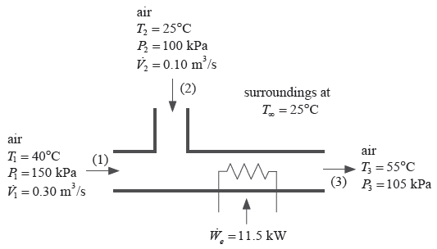
- Determine the mass flow rate of air exiting the heating unit at state (3). [10]
- Determine the rate of heat transfer FROM the device to the surroundings. [13]
- Determine the total rate of entropy generation resulting from operating the device. [17]

Unit 4 Heat Effects
2k11 Sem 3 Final
QUESTION 4 (25 marks)
Chlorine is produced by the reaction:
4HCl (g) + O₂ (g) = 2H₂O (g) + 2Cl₂ (g)
The feed stream to the reactor consists of 60 mol-% HC1, 36 mol-% O₂, and 4 mol-% N₂, and it enters the reactor at 823.15 K. If the conversion of HC1 is 75% and if the process is isothermal, how much heat must be transferred from the reactor per mole of the entering gas mixture?
2k11 sem3 Mid semester test 2
Question #2 [35 marks]
An equimolar mixture of nitrogen and acetylene enters a steady-flow reactor at 298.15 K (25°C) and atmospheric pressure. The only reaction occurring is:
N₂(g) + C₂H₂(g) 2HCN(g)
The product gases leave the reactor at 873.15 K (600°C) and contain 24.2 mole-% HCN. How much heat is supplied to the reactor per mole of product gas?

Unit 5
2k11 sem3 Mid semester test 2
Question #3 [30 marks]
A binary mixture of Ethanol (l) and l-propanol (2) with a mole fraction of $z_{1}$ = 0.25 is flashed to conditions of T = 360 K and P = 0.8 atm. Assuming that Raoult's law applies, determine:
- the equilibrium mole fractions $x_{1}$ and $y_{1}$ of the liquid and vapor phases formed,
- the molar fraction V of the vapor formed, and
- the fractional recovery R of species 1 in the vapor phase (defined as the ratio of the moles of species 1 in the vapor to moles in the feed).

